# For development

Since the server and client run on the same computer, we only need the one PC with windows as the development environment and production environment. The setting of development environment and production environment be written in to the file named development.py and production.py ( which are placed under the folder djecommerce\settings). Both of them are extend the base.py which define the common parts of the two files. Let me explain all of them in the tables.

|  |  |
| --- | --- |
| Name | Description |
| base.py | It used the module named python-decouple helps you to organize your settings so that you can change parameters without having to redeploy your app.  Also, in this file, it set the basedir and all the apps that need to run. For example, we should add our app named core into the INSTALLED_APP  And also set the place to put the template and the folder to put js files, css files and image. |
| development.py | Set the database, in our project, we used the sqlite3  And open the debug and the debug tools  And set host as 127.0.0.1 |
| Production.py | it doesn’t work since our server and client is not separated, it just to complete the whole structure. And for content, it defines the host, database. |

For the large angle, we choose to use the python whose version is 3.7 and the Django whose version is 2.2. And other modules should be used we recorded them in the requirements.txt. So, if another one download it, it can the run the command *pip install -r requirements.txt* to install all the required modules. The module required can be seen in this picture below.( Note: the version of Python and its corresponding Django is most important, the wrong version will lead to lots of error)

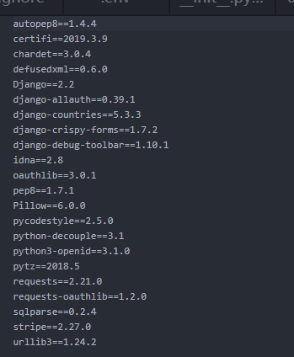

# For testing

Automated testing is an extremely useful bug-killing tool for our website. Django’s unit tests use a Python standard library module: unittest. This module defines tests using a class-based approach. But we did not use the unittest module directly. We used the use case encapsulated by Django.

# For deployment